introduction
The USA Counties are provided by Geoplan. The data provides a spatial reference for the each of the Counties in the USA. The layer is useful for providing a reference to the distribution of the Counties in the country, as well as catchment and territory analysis

If you have any questions relating to the information in this document, please contact Geoplan Support on +44 (0)1423 722719, or email support@geoplan.com. The Support Team is available Monday – Friday, 9.00am – 5.00pm GMT, excluding UK public holidays.

Images
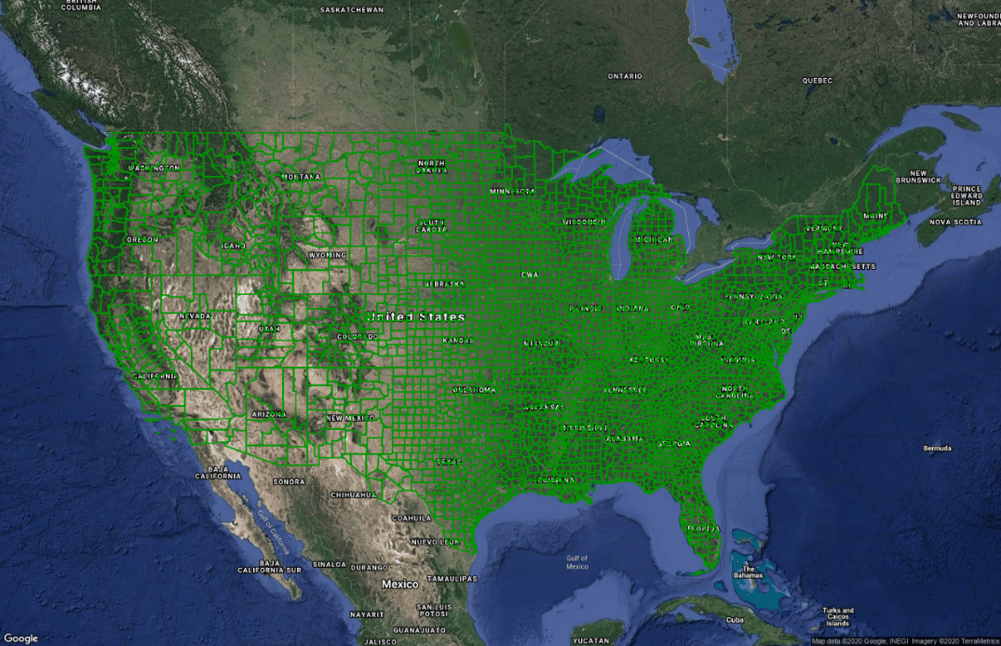
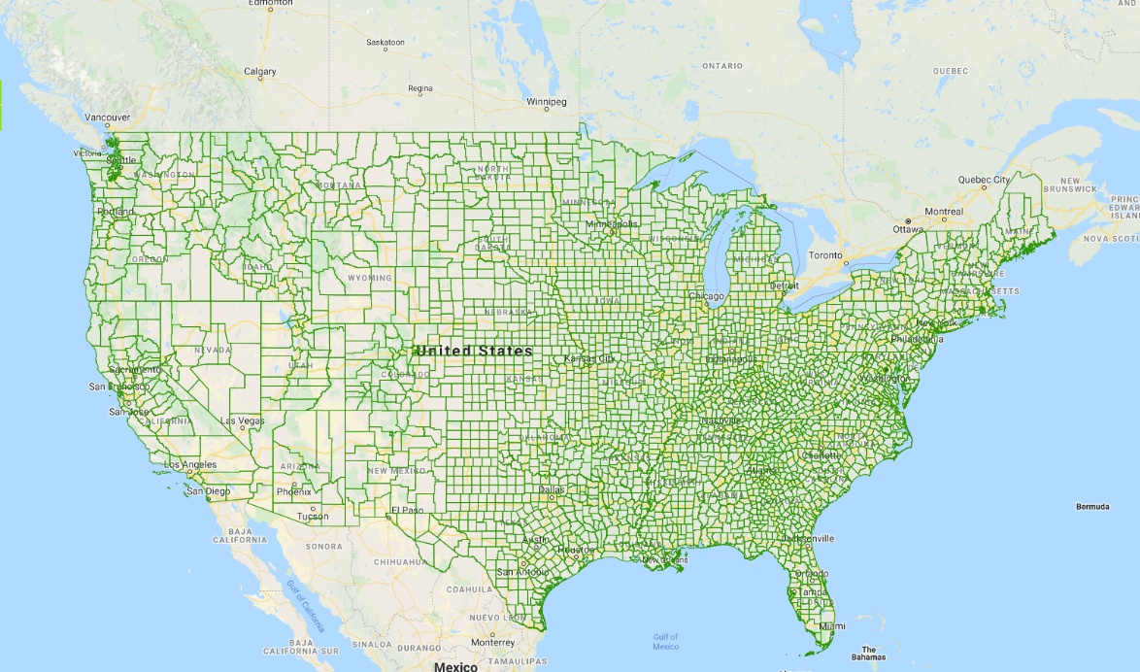

Data
Layer Name | Total Records
Counties | 3233
Source – Geoplan
Recency – 2020
Geographical Coverage and Accuracy – USA and its Inhabited Territories
Projection – WGS84, EPSG: 4326
Available Formats – SDL
Layer Type - Boundary

Data Health
Data Health | Green
- The most up to date States.

License INformation
License type- Annual
Update cycle – Updated when required

FURTHER INFORMATION
Data Specification
Header Record | Description | Example | Data Type | Maximum Field Size
COUNTY_ID* | The id of the county | 20201 | Number | 5
COUNTY | The name of the county | Washington | Text | N/A
STATE | The state the county is in | Kansas | Text | N/A
CTY_STATE | The label on the layer | 1Washington, Kansas | Text | N/A
*Import Key Column

Copyright
Copyright Information: GEOPLAN © Geoplan Spatial Intelligence Limited.

